**PART A**

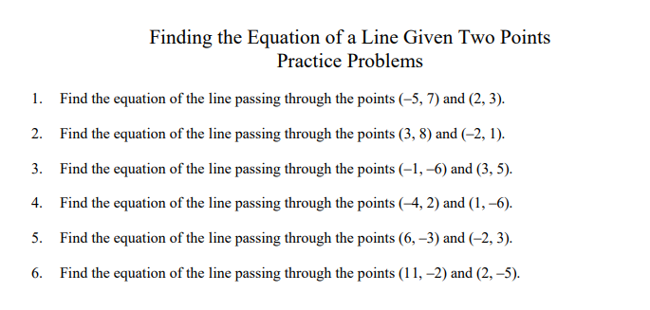

**PART B**

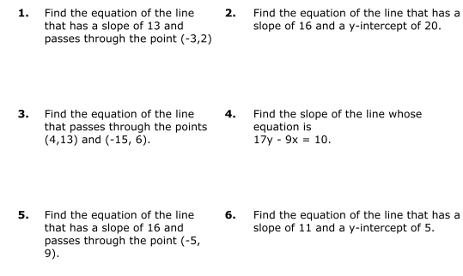

**PART C**

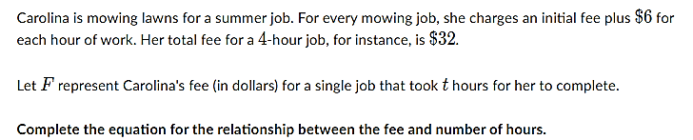**1.**

1. FIND THE SLOPE
2. FIND THE Y-INTERCEP
3. FIND THE ECUATION OF THE LINE